Allison Wiffen Tel: 07880 52 00 71 www.awceramics.co.uk

Jewellery Styles

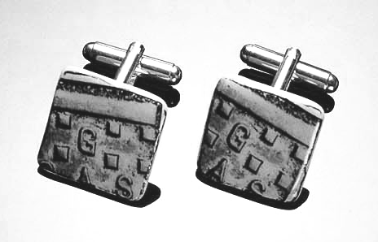  Cufflinks 18 or 20mm | 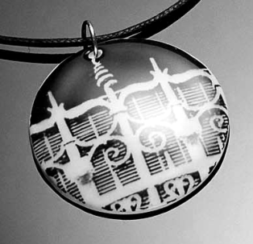  Pendant 48mm
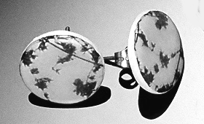  Stud earrings: 20mm | 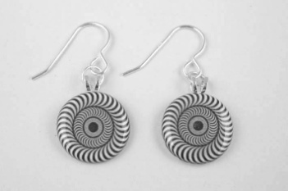  Tiny dangly earrings  16mm disc
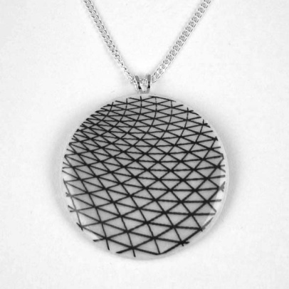  Pendant on silver 35mm | 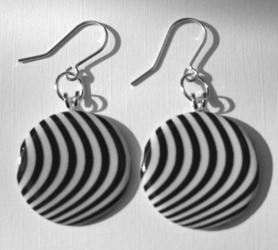  Large dangly earrings  28mm disc
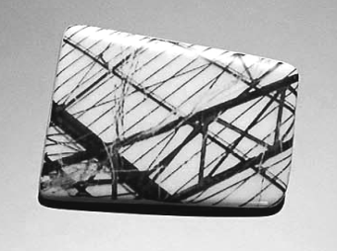  Asymmetrical brooch | 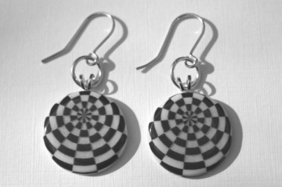  Small dangly earrings  20mm disc

